MVC：Model, view,controller. In an MVC application, the view only displays information; the controller handles and responds to user input and interaction. In the MVC pattern, the controller is the initial entry point, and is responsible for selecting which model types to work with and which view to render (hence its name - it controls how the app responds to a given request).

Routing: Defining URL naming patterns

Model validation: The validation attributes are checked on the client side

Dependency injection: ???

Get started: being familiar with setting up and basic information.

Controller:

Attention: 1.name has to append Controller like HelloWorldController

2. ViewData dictionary was used to pass data from the controller to a view.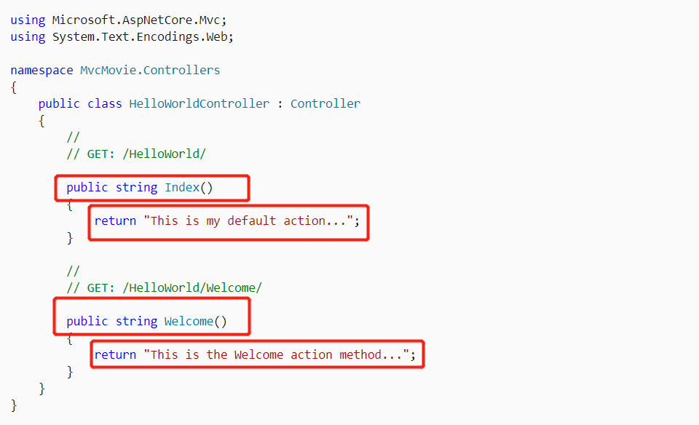

/[Controller]/[ActionName]/[Parameters]

Model: class->ID—database for primary key